Requesting Access to Academic Profile – Unit administrative Roles

Faculty and Academic Staff (FAS) are automatically added to the Academic Profile (AP) system based on their HR appointment.

Access for administrators, proxies, and others is requested using one of two eARMs located at TeamDynamix. You will be prompted to sign in with your MSU NetID and password.

1. Select “Academic Profile – Unit Administrative Roles” from the Access type list and click Request.
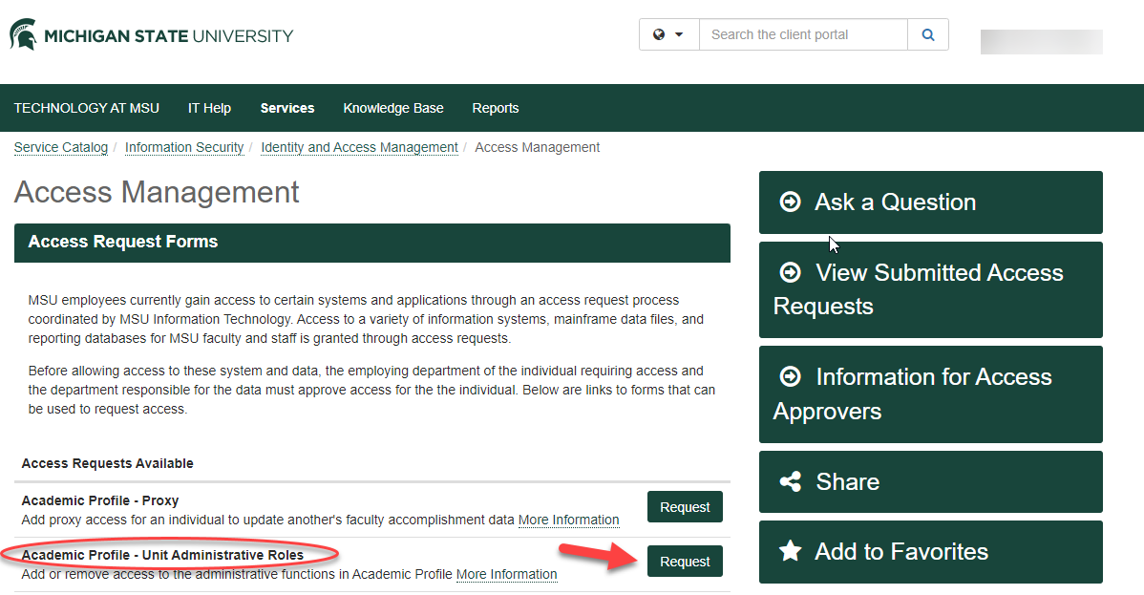
2. Select end users by entering name, MSU NetID, or MSU username and click Search. A dropdown box will appear below. Click on down arrow to choose faculty name and then click on Add User. The faculties user name, name, employing organization will appear.
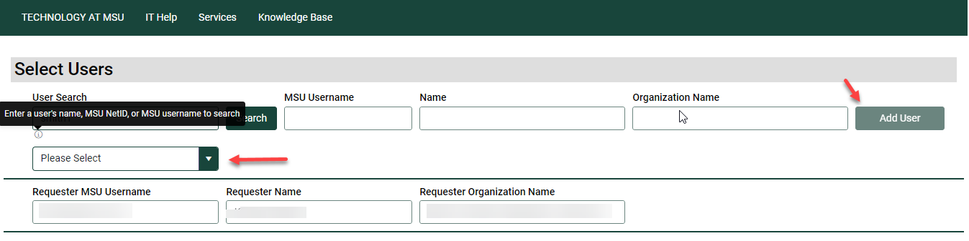
3. This section of this screen asks for Unit Administrative Roles level and type of access needed.

Level: University, MAU/College, or Organization/Department
NOTE: Only one level should be selected on the ARM form. MAU/College access includes all departments within the college. University-level access is typically only granted to data stewards and central offices.

Access Type: Read Only, Reports Only, Update (includes reports; College or Department level.
NOTE: Only one type should be selected on the ARM form. Your responsibilities should determine which type of access is appropriate for you.

Under the appropriate access level, use the dropdown option to ADD the Access Type.
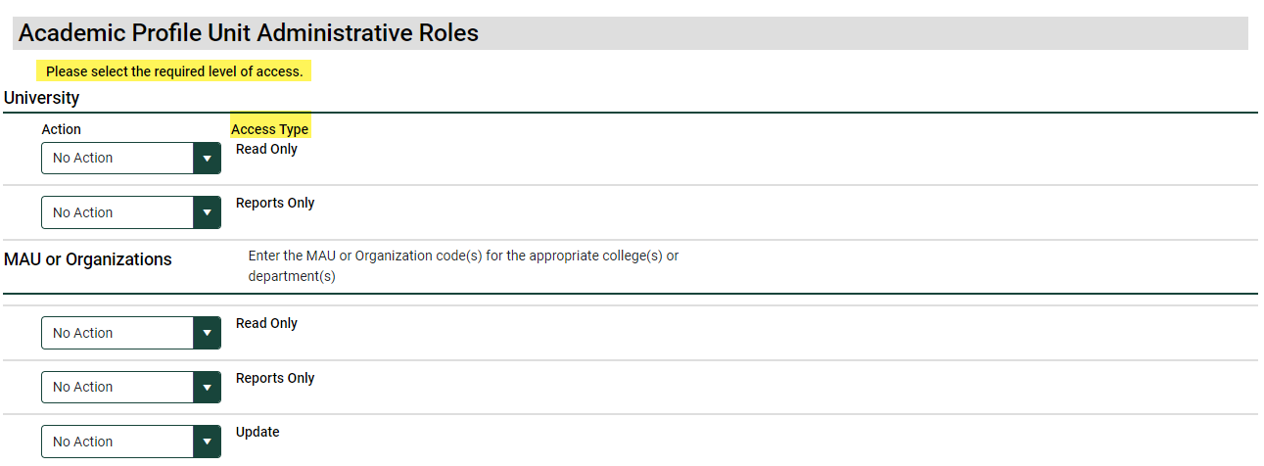
4. This section asks the user to verify whether they have completed FERPA training and have read the Institutional Data Policy and signed the related acknowledgement form. These two items are required to be granted access to AP.
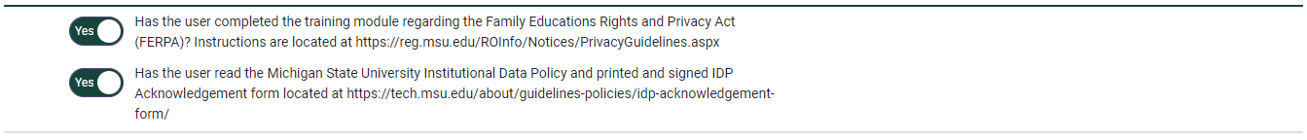
5. This comment box is optional. The last two steps are to 1) Click the Check Form box to ensure the form has been successfully completed. 2) Click on the Submit Access Request box.
